Regional Telecommunications Review Submission
Better Internet for Rural, Regional & Remote Australia (BIRR)
Overview
At the end of October 2014 the Facebook group Better Internet for Rural, Regional and Remote Australia was formed. It now has approximately 1500 members. Our aims are to provide information and support on telecommunications services to those living in rural, remote and regional areas. We regularly share data saving tips, media articles and questionnaires to assist those having difficulty accessing equitable telecommunications services. Initially this began as an internet help group but has now also covered areas such as landlines and mobile coverage. Three admin manage the page – Kristy Sparrow who resides north of Alpha, Kylie Stretton who lives West of Charters Towers and Kristen Coggan from Condamine all located in Queensland.
Our group strongly believe that equitable telecommunications services are imperative for regional Australians to keep up to speed with their urban counterparts. From health to education, business to social welfare it is essential that all Australians, regardless of their location, are provided with internet services that meet their needs.
People in regional areas use internet and mobile services for a wide array of needs including weather forecasts, flood and fire information, education, business, ordering supplies and parts that may not be available locally, banking, cloud computing including accounting, social networking, health and lifestyle. Their reliance on telecommunications differs from those in urban areas, for example the need to access a bank could involve a 600km round trip for a rural customer if the internet is not working. Areas such as telehealth, educational webinars, cloud accounting etc would be utilised by more regional customers if their internet services met their needs. Currently children educated by distance education have been severely disadvantaged by limited internet downloads and poor speeds. This has been ongoing for several years and needs to be addressed immediately. With the introduction of a new national curriculum, more on air classes and thus more data is required. Many children are unable to use webcams and continually drop out of lessons. Waiting another 12 months for the Long Term Satellite is not a satisfactory solution for these children who are in their formative years of education.
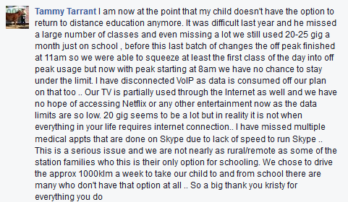
LACK OF INFORMATION FOR CONSUMERS
There is a severe lack of information surrounding telecommunications in regional areas. Providers advertise large urban plans with unlimited downloads whilst plans that are available for regional people are rarely advertised, upgraded or costs reduced. Provider help lines are not helpful, many consultants being unware of the circumstances of regional customers or the technology used to deliver services. Different service technicians provide different information, often conflicting, resulting in even more confusion among regional users. The information on what types of services, plans and data limits available needs to be more streamlined and easily accessible. A dedicated website is one idea to help regional consumers navigate the services available to them, the website could also contain data saving tips and information specific for rural users. We have posed this question in our group, with the following responses.


From our research we have found the majority of regional users have one (or more) of the following types of internet:
Next G Wireless Broadband
While this service from our experience meets users speed requirements (except in high congestion areas), the pricing structures and download limits are prohibitive. Telstra appears to be the only provider in the majority of regional areas and it is this lack of competition that exacerbates the problem. Go Mobile Broadband plans are not shaped, the largest plan being 25GB /month at a cost of $160/mth with every extra GB $10. Bigpond Mobile Broadband plans are shaped, the largest plan being 25GB for $160/mth with no extra data available. Once users reach the 25GB the service is slowed to old dial up speeds and is not useable. The 25GB plans are not widely advertised and many consumers are unaware of the difference between plans or the amount of data they can access.
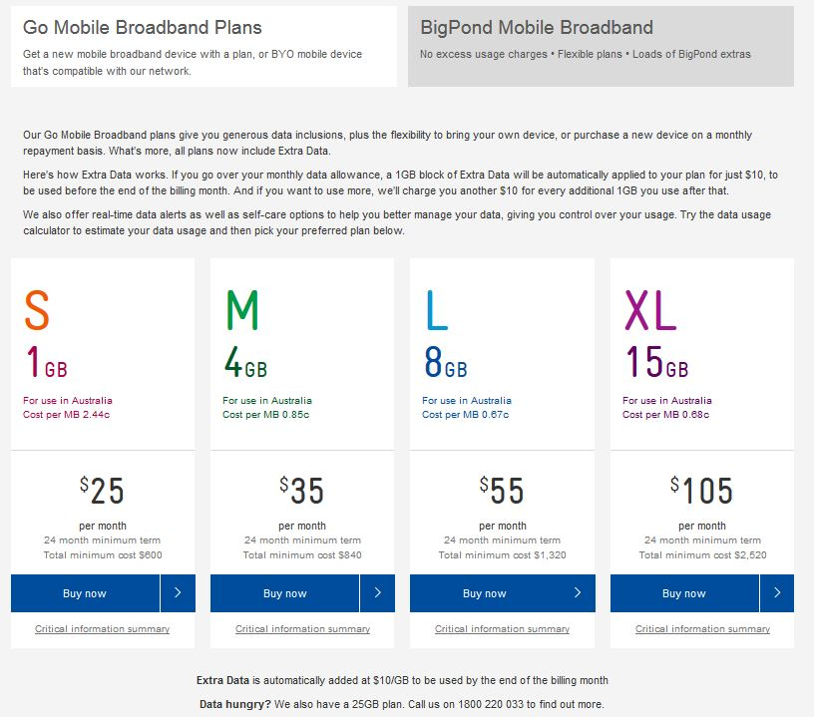
With the recent mobile blackspot funding announcements and the ridiculously slow satellite speeds, mobile broadband is becoming a preferred option for many in regional areas. Although many customers using this form of internet have no other option, as mobile broadband is seen as “metro comparable” and as such they were ineligible for NBN Satellite. The above plans are certainly not metro comparable in price or download limits and are very frustrating with the limits imposed.
There would be a greater uptake of mobile broadband if more information was available on celfi boosters and aerials. Subsidies to help with the large costs of these devices would also help people who rely on this form of internet.
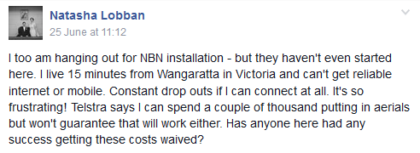
Many customers have reported unexplained excess usage charges on their mobile broadband accounts. When the cost of services are so expensive, there needs to be a better system of viewing usage for these customers and more information from providers to help with excess usage concerns. Further studies into 4G modems operating in 3G areas would be beneficial as well as assistance from Telstra when issues such as the one below occur.
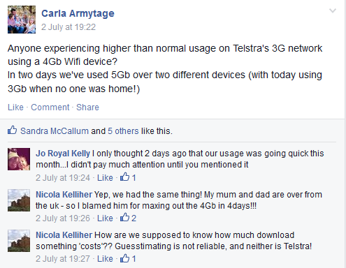
Unmetered sites for regional areas could be a useful way to cut down data usage. Our group has investigated options for un-metering certain education sites however the platform used by Education Queensland is used by all Queensland schools and un-metering would be extremely expensive for Telstra. To date we have not been able to find a site that could be used for distance education students only and thus un-metered to benefit regional education users. Education Queensland (and other states educational bodies, as the national curriculum becomes adopted) also need to understand that regional families do not have access to the data required to complete the papers they are writing.
Telstra should be encouraged to offer a more competitive pricing structure for mobile broadband and more support to those in regional areas who need assistance. A plan for those who use mobile broadband as their only access to the internet should be established and this should also consider the data allowance needs of customers. Current plans do not differentiate between urban users with 3g mobile modems or USB’s (wanting mobile data for travelling etc) and regional ‘fixed’ modems (the only internet available). The current 25GB limit is a huge concern and does not meet the educational, business, health & welfare needs of regional Australians. This needs to be addressed by Telstra as an immediate priority.

IPSTAR SATELLITE (OLD SAT.)
There are many regional users still on old ipstar satellite services. Over time their needs may have changed and what seemed like a plan 2 or 3 years ago may now be very limiting. An example of this is the family below who now are trying to find alternatives for affordable internet before they begin prep with Distance Education. These families should be given a priority placement on the new Long Term Satellite.
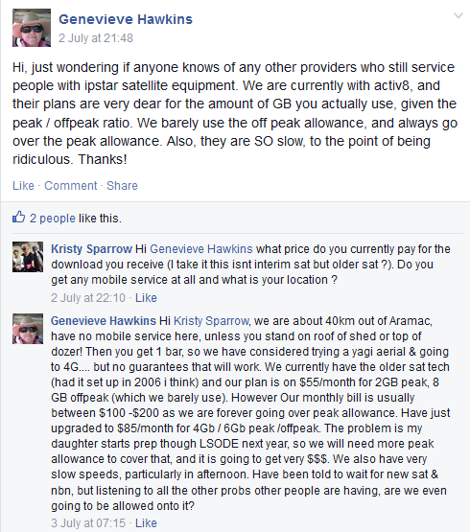

And another family on IPSTAR satellite demonstrates her data usage and costs.
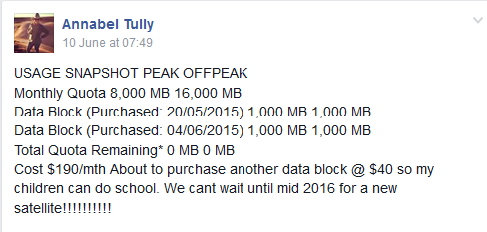

Interim NBN Satellite (NBN co via various providers)
NBN Interim Satellite has not meet user expectations, it has been oversubscribed and current speeds are causing considerable angst across Australia.
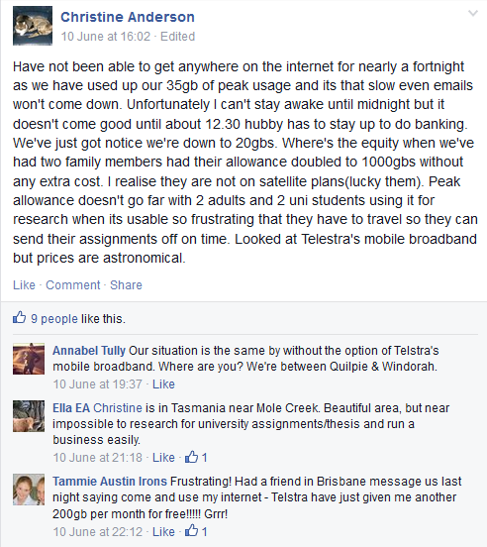
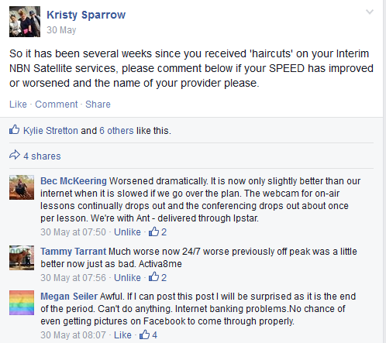

Recently there has been a reduction in plan sizes to between 20GB and 50GB depending on the provider. One provider (Activ8) has informed customers that when they surpass the 50GB limit their accounts will be suspended until the next billing period. Despite the ‘fair use policy’ and reports by NBN Co that speeds have improved, they appear to be worse than ever before with many of our page members. Users are finding pages so slow to load that they are using excessive data just to be able to open webpages and emails. Monitoring systems set up by NBN providers often do not work as the service connection is too slow to load the usage page. Another 12 months of internet services at speeds such as those described will have devastating effects on education and business of regional customers.

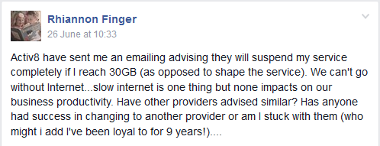

Through our group we have been able to ask Paul Fletcher MP, Federal Member for Bradfield & Parliamentary Secretary to the Minister for Communications a reason for the slow speeds. This was his response.
1/7/2015
“Regarding the Interim Satellite Service: Mr Fletcher pursued the issue you raised that despite nbn's efforts to improve user speeds on the ISS, many users were still reporting speeds getting worse.

There are two elements to the actions being taken to improve user speeds on the ISS: first, nbn has made improvements to the management of the satellite network so that average download speeds across the network have increased. The second element is action required on the part of the retail service provider (RSP) to manage their part of the network. It is this second element which may be the reason that some users are complaining of poor performance despite the measures being implemented by nbn to improve the ISS.

As you are aware, since nbn began introducing measures to improve ISS speeds some RSPs have reduced download limits on their plans, in some cases from 60GB down to 20GB per month. This is a necessary step in RSPs managing network capacity to deliver acceptable service levels to all of their users. Analysis by nbn found that the top 2% of users on the ISS were taking up around 20% of the capacity on the service - unfairly slowing the service levels of all other users.

Network monitoring performed by nbn has found that RSPs which are compliant with new 'fair use' controls have seen improvements in end-users speeds. However, some RSPs have yet to implement the necessary measures to deliver service improvements across their user base, and nbn is actively pursuing these RSPs to ensure they comply with new fair use controls.

RSPs which have failed to comply with these new fair use controls have been sent notices alerting them of their obligations, and RSPs which have continued to breach the fair use controls are now having their services actively managed by nbn to enforce compliance. This step is being taken to ensure users receive improved ISS performance, and nbn is measuring network performance to ensure RSPs comply. These new enforcement measures have only recently been introduced (following a series of formal notices sent to RSPs), and nbn will continue update the Parliamentary Secretary on the outcomes of this process”.

8/7/2015
“As for the complaints on your page about the Interim Satellite Service still being low-speed - my initial reaction would be (without knowing the specifics of the individual users' circumstances) that it could be related to what I described in my previous email - that some Retail Service Providers (RSPs) had not been complying with Fair Use Controls and nbn has only recently begun actively managing these services to ensure they comply with these controls.

We will be getting ongoing updates from nbn about the effectiveness of these new measures so I hope that we may see positive results in the near future.”
While we appreciate that they have attempted to fix the issues many people are very sceptical of the ability of the new Long Term Satellite to cope, considering the Interim Satellite was not managed well at all. The suspension of internet services once customers have reached their usage has considerable long term effects on education and business.

Long Term Satellite
The launch of the long term satellite has consumers posing many questions which to date have not been answered.
- Will there be data limits imposed and will these be fair and equitable limits?
- Will there be a huge improvement in speed?
- Will the pricing structure be comparable and equitable to what is available in urban areas?
- Will current mobile broadband users be entitled to a place on the new satellite?
- Does the satellite have enough bandwith to cater for current needs and ongoing projected needs for regional Australia?
- Will customers on old IPSTAR satellites be given priority of placement on the new long term satellite service?
- Will there be new equipment need and further costs for the user?
- Will telephone services be via Long Term Satellite in the future?
The above questions need to be answered immediately, regional people need to make decisions regarding business, education and staffing and they need answers to enable them to make the correct choices.
The NT government provide the equipment and connection costs for satellite internet for distance education students in their state. STARS is a designated satellite for health, education, and emergency services.
http://www.ascs.com.au/xstd_files/STARS%20brochure.pdf%2015.09.pdf
This system appears to work very well and perhaps could be looked at for other states. Could there be a designated satellite for all of Australia’s distance education students?
Thought needs to be put into off peak times on the new satellites so that these meet the needs of regionally based consumers, the majority of distance education ‘on air’ lessons occur between 8am – 12pm. Current satellite off peak times are not proving user friendly and many students are missing essential teacher contact due to not having enough peak download availability. The recent change in peak times has disadvantaged regional users greatly. Once all the peak usage is used up, off peak usage is also suspended.
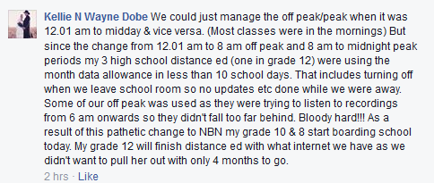

Telephone Landlines
There have been several incidences recently where landlines have taken up to 6 weeks to repair. One family, with 2 children enrolled through Distance Education, missed 3 weeks of essential on air lessons via the telephone due to their phone outage.
http://www.abc.net.au/news/2015-05-25/qch-phone-outages/6493930
Our page contacted Telstra Country Wide to escalate the issue and were fortunate enough to be able to have a repair man attend within 2 days, he took ½ hour to fix the problem despite the family being told it would be another 2 weeks before repairs could occur. Another member of our page was without her landline for 6 weeks.
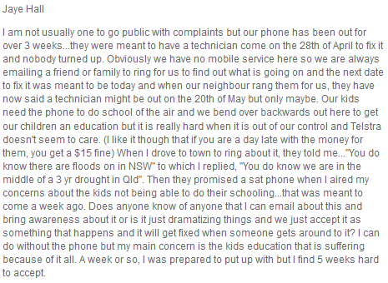

For those in remote areas, landlines are an essential communication and education tool, in times of emergency it is imperative that landlines are in working order. Repair times are far too long and extremely frustrating. Many consumers are unaware of the Universal Service Obligation and how to escalate faults and complaints. There needs to be dedicated rural and remote specialists available via phone and email. Repairs should be prioritised for customers with education and health needs.
The future of telephone services in regional areas also needs to be investigated. Parts for radio phones are becoming scarce. From our interactions with members on our page there is a concern that the new Long Term Satellite will be used for voice based calls. Further trials into Satellite for voice calls need to be conducted as many testing this have reported severe latency issues.
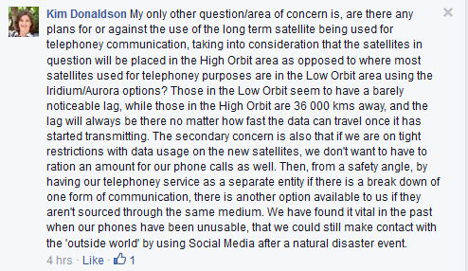

Mobile Coverage
Mobile coverage needs to be prioritised in black spots across regional Australia. The recent mobile blackspot funding announcements will be a help in covering some of these areas. We acknowledge and thank the federal government for the blackspot funding and state government and local councils who were able to contribute extra funds to stretch out this funding to cover more base stations. Major highways should be prioritised as safety concerns of travellers are paramount. Over 70% of Australia’s land mass has no mobile coverage and many areas are very congested especially in new mining communities and areas of high tourist traffic. Investigations into using current radio phone towers as repeaters for mobile services would be helpful.
There are been reports from many members on our page of congestion issues on certain mobile towers around Australia. As many customers are reliant on these towers as their only form of internet it becomes very frustrating when the congestion levels are so high that the internet becomes un-useable.
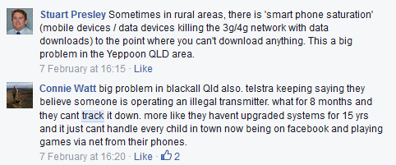

General Comments
There needs to be an established service guarantee for internet services Australia wide, this should be equitable in terms of speed, download capabilities and costs. If this does not occur regional Australia will be left behind, current services in regional areas have been described as more of a goat track than a super highway.
The Long Term Satellite is being pushed by the government as the answer to all of regional Australia’s internet concerns, yet many questions remain unanswered as to how the service will be managed and if it will cope with future demands.
The lack of telecommunications services in regional areas is a significant factor in limiting business and job growth. Families are moving away from remote areas as they can’t access essential internet downloads and speeds needed to educate their children. The gap between city and country grows wider.
